EX 1:

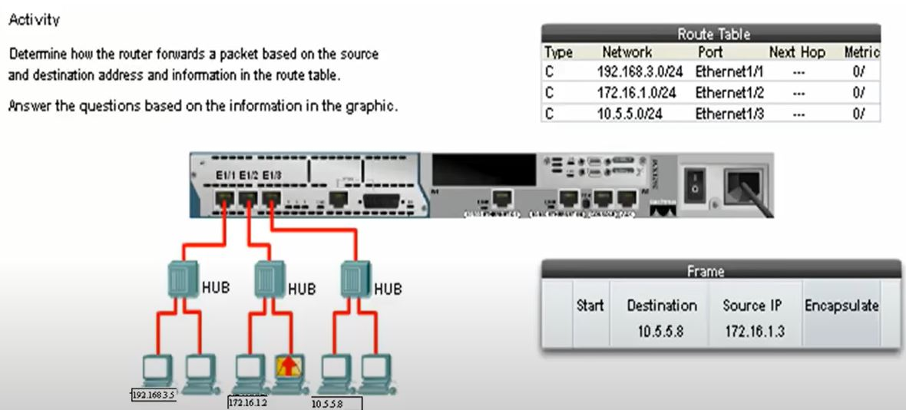

1. What is the default gateway address used to forward this packet to the router?

* 192.168.3.1
* 192.16.1.1
* 10.5.5.1

1. When the router recevives this packet, to which interface will the router forward the packet ?

* Ethernet1/1
* Ethernet1/2
* Ethernet1/3

EX 2:

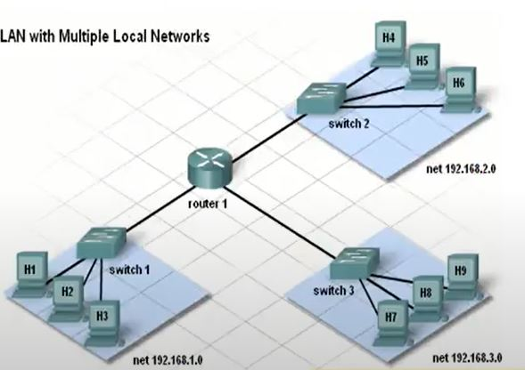

圖1

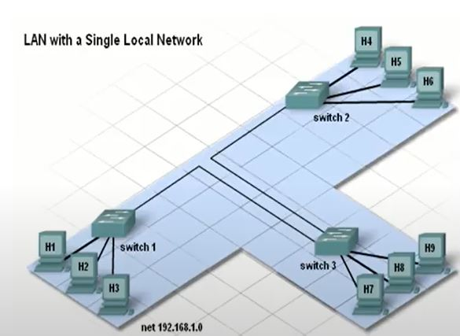

圖2

1. How many croadcast domain?

Ans:圖1 = 3，圖2 = 1

#網路區域

1. How many collision domain?

Ans:圖1 = 12，圖2 = 3+3+3+2 = 11

EX 3:

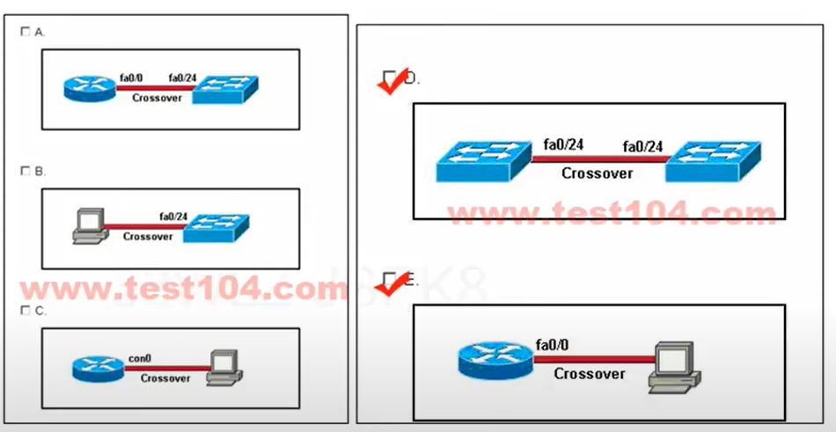

Which two topologies are using the correct type of twisted-pair cables? (Choose two)

Ans:

On the picture

Explation:

None

#C.con0代表console line